**Data Analysis and Visualization Report: Exploring Economic, Demographic, and Health Indicators**

**Overview**

In this report, I analyze and visualize key insights from the gapminder dataset, which contains information on various countries over time. The focus is on economic indicators like GDP per capita, demographic metrics such as population, and health statistics such as life expectancy. Several charts and plots are used to convey the relationship between these variables, helping me gain valuable insights into global trends and patterns. All analyses are based on data from different time periods, primarily focusing on the year 2007.

**1. Economic Indicators**

***1.1 Proportion of Countries by Continent***

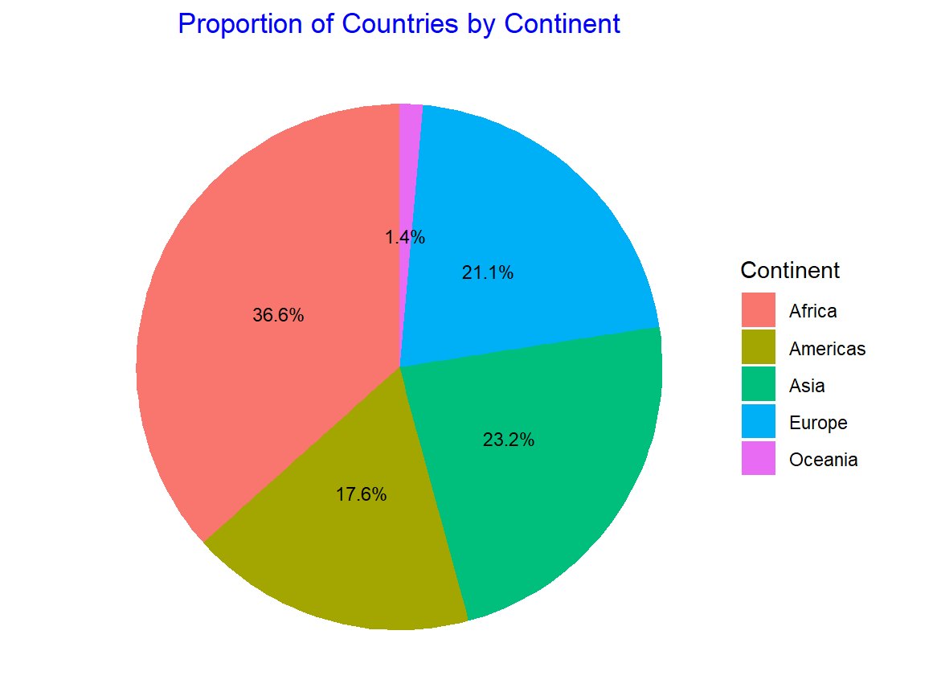

A pie chart was used to illustrate the proportion of countries by continent in the dataset. Each slice of the pie represents a continent, with its size proportional to the number of countries in that continent. The chart reveals that the highest number of countries belong to Asia and Africa, whereas continents like Oceania and Europe represent fewer countries. This visualization highlights the disparity in the number of countries across different continents.

***1.2 Average GDP per Capita by Continent***

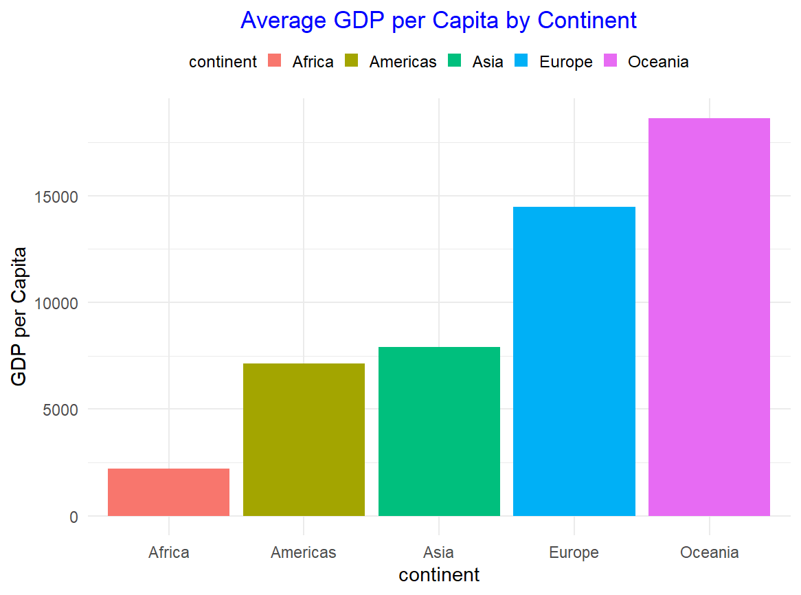

A bar chart was used to show the average GDP per capita across different continents. The results reveal that Europe and Oceania have the highest average GDP per capita, significantly surpassing other continents. Conversely, Africa has the lowest average GDP per capita. This chart emphasizes the economic disparities that exist globally, particularly between the developed and developing regions.

***1.3 GDP per Capita Heatmap***

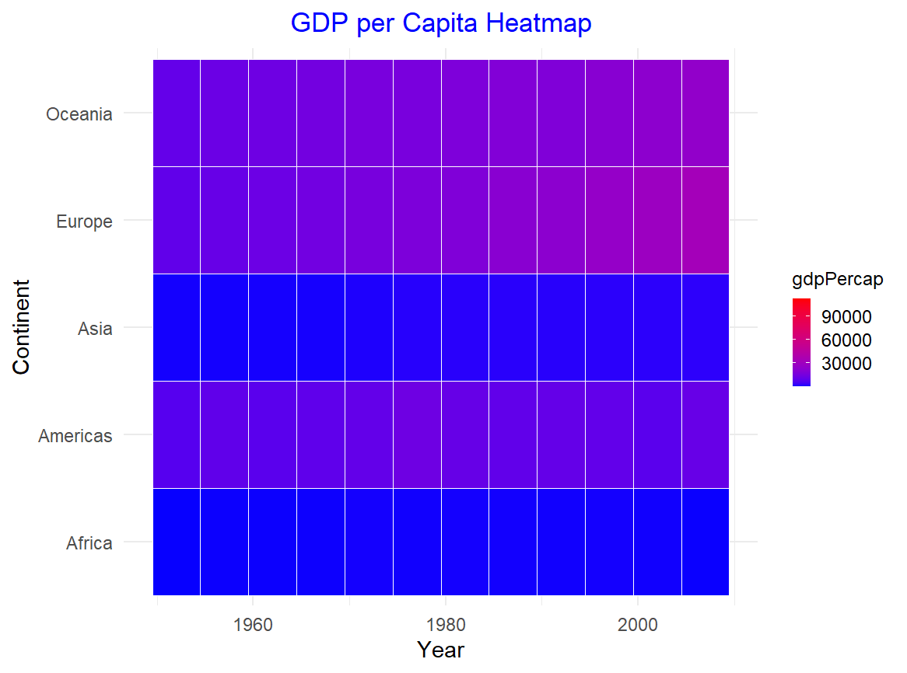

A heatmap was created to visualize GDP per capita across different continents over time. The heatmap shows that GDP per capita generally increased in most continents from 1952 to 2007, with sharp rises in Europe and North America, reflecting economic growth. However, the heatmap also reveals that Africa has consistently had lower GDP per capita throughout the years, which is crucial for understanding the slow economic development in certain regions.

***1.4 Choropleth Map of GDP per Capita by Country (2007)***

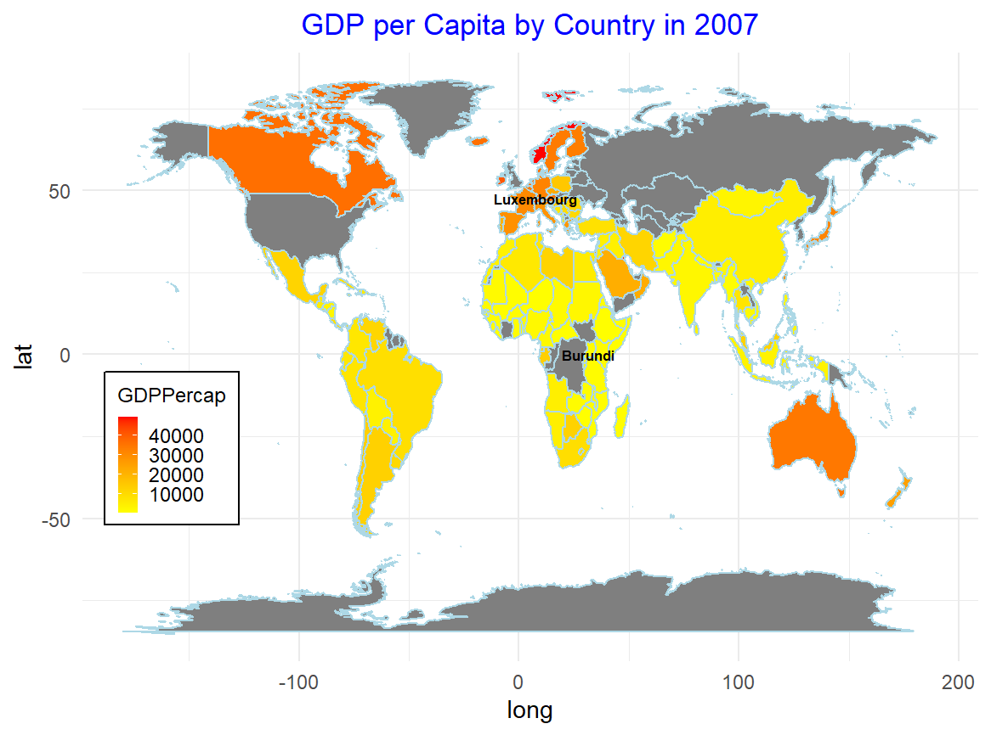

A choropleth map was used to visualize the distribution of GDP per capita across countries in 2007. The map highlights significant disparities, with countries in North America and Europe showing high GDP per capita (e.g., Luxembourg and the United States), while countries in Africa (e.g., Burundi) exhibit much lower GDP per capita. This highlights global inequalities in economic development, with a clear divide between wealthier and poorer nations.

**2. Population and Demographics**

***2.1 Population by Continent Over Time***

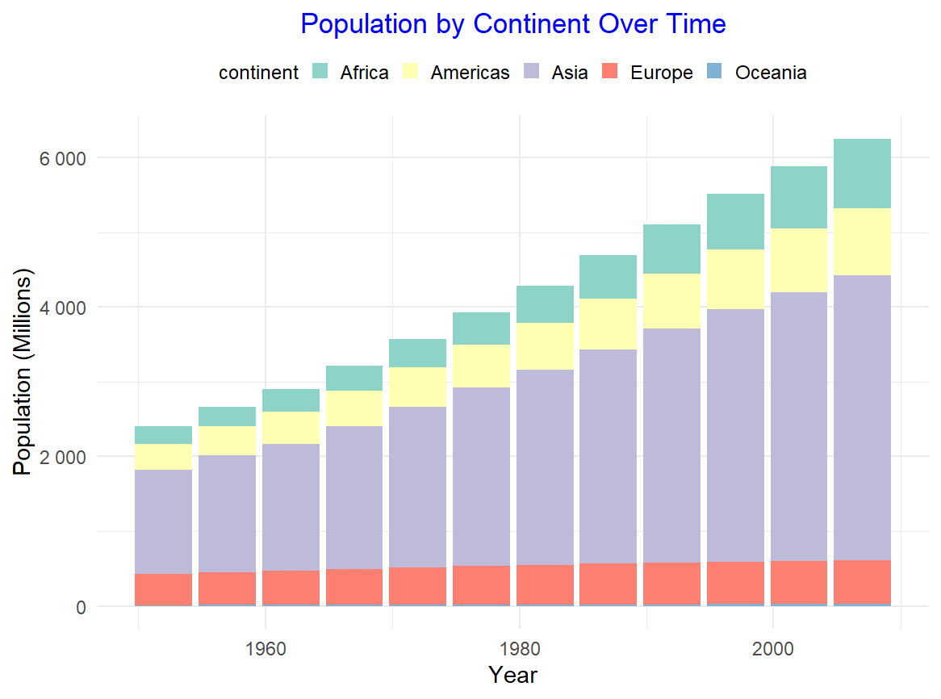

A stacked bar chart was used to show the population distribution by continent from 1952 to 2007. The chart reveals that Asia has had the largest population increase, with countries like China and India contributing significantly. Africa's population has also grown rapidly, while Europe's population growth has slowed or even declined during this period. This chart is important for understanding demographic trends, especially the growth of populations in developing countries.

***2.2 Population Flows Between Continents (1952 to 2007)***

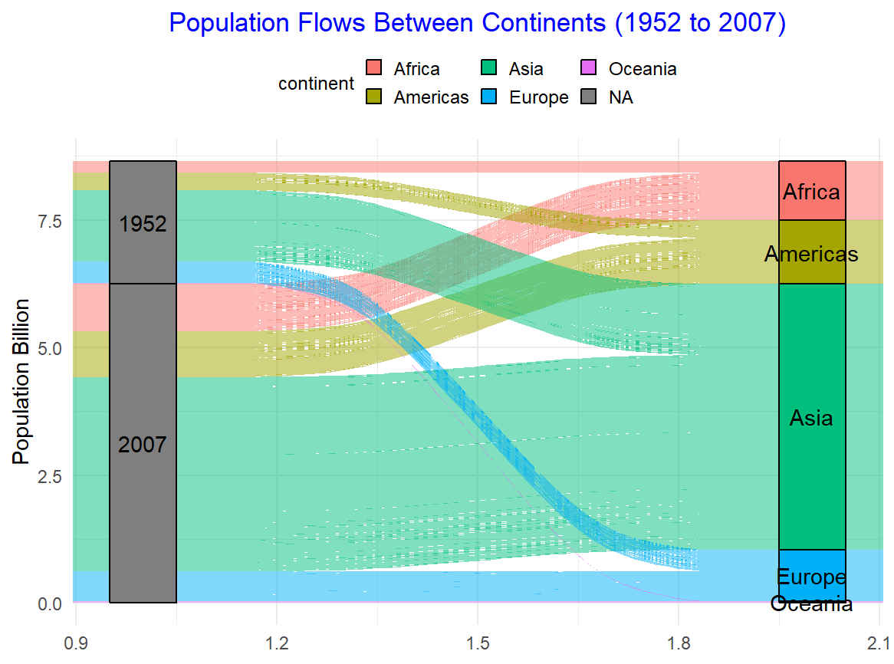

A Sankey diagram was employed to visualize population flows between continents between 1952 and 2007. The diagram clearly shows that Asia and Africa experienced the most significant population growth, while Europe and North America had minimal population changes. This visual emphasizes migration trends and demographic shifts across continents over time.

***2.3 Population Distribution by Continent (2007)***

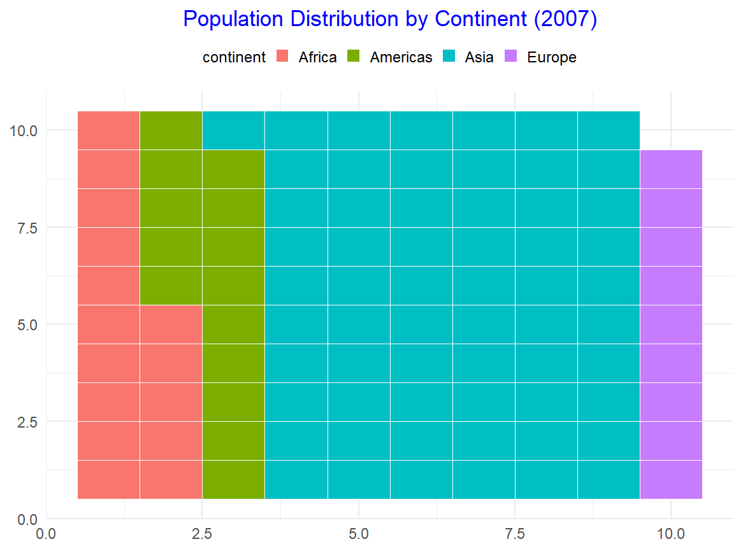

A waffle chart was created to represent the population distribution by continent in 2007. This chart confirms that Asia and Africa dominate the global population, with Europe and Oceania having much smaller shares. This visualization offers a clear, proportional representation of the global population across continents, reinforcing the population dominance of Asia and Africa.

**2.4 Top 10 Populated Countries in 2007**

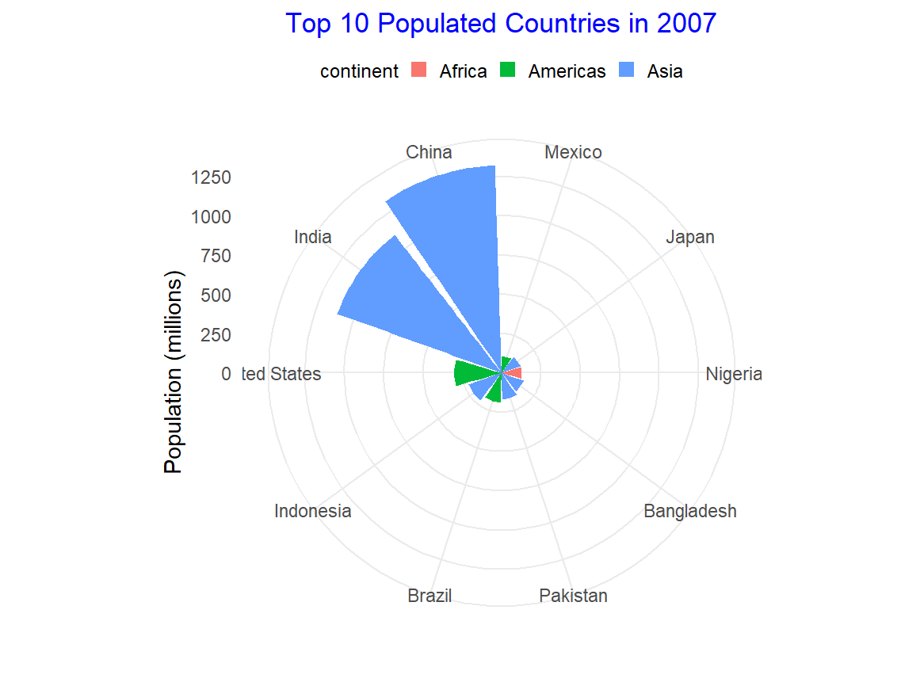

A circular bar plot was used to highlight the top 10 most populous countries in 2007. The plot shows that China and India have the largest populations, followed by countries like the United States and Indonesia. This chart underscores the dominance of a few countries in the global population landscape.

**3. Health and Life Expectancy**

***3.1 Life Expectancy Distribution by Continent***

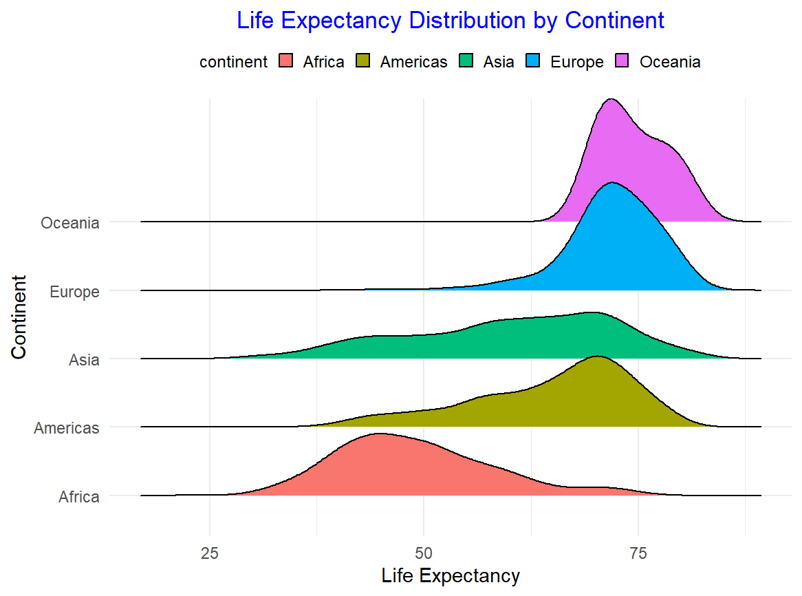

A ridgeline plot was used to show the distribution of life expectancy by continent. The plot reveals that Europe and Oceania generally have higher life expectancies, with Africa having the lowest. This visualization highlights the health disparities between continents and the varying quality of healthcare systems and living conditions.

***3.2 Average Life Expectancy Over Time by Continent***

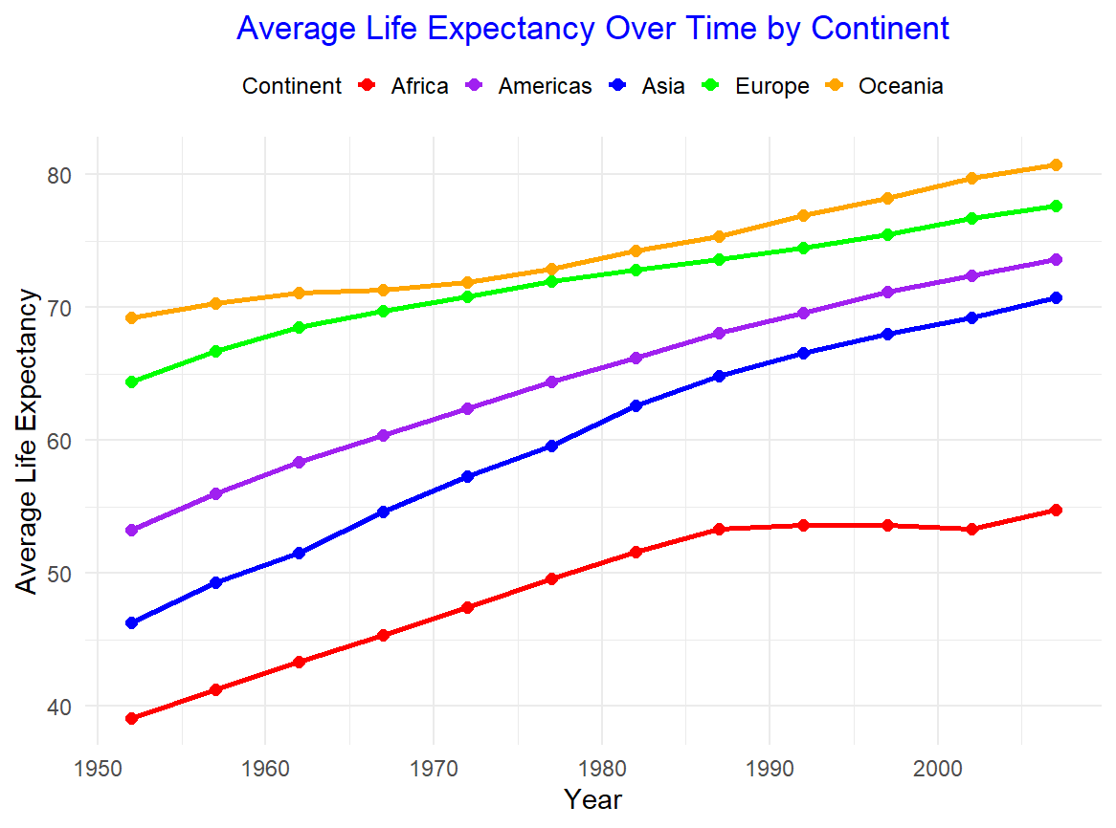

A line plot was used to show how average life expectancy has changed over time by continent. The plot reveals a general upward trend in life expectancy, with Europe and Oceania seeing the most significant improvements. However, Africa still lags behind in terms of life expectancy, which is an indicator of ongoing health challenges in the region.

**4. Combined Economic and Demographic Trends**

***4.1 Scatterplot Matrix of Key Economic Indicators***

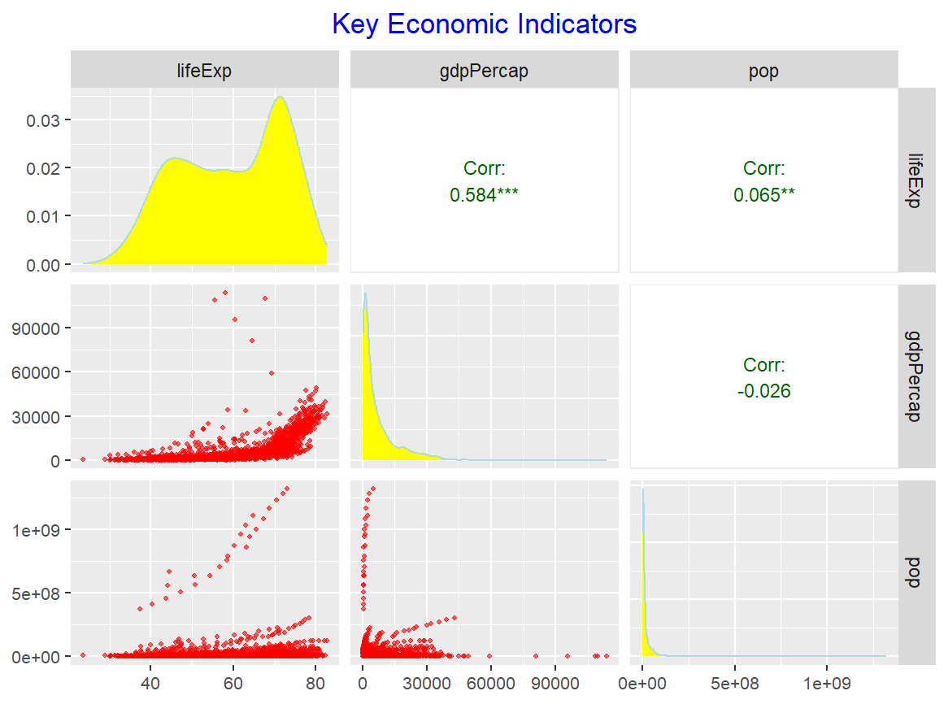

A scatterplot matrix was used to explore the relationship between life expectancy, GDP per capita, and population size. The scatterplots show that countries with higher GDP per capita tend to have higher life expectancy. Moreover, larger populations do not necessarily correlate with higher life expectancy, which suggests other factors such as healthcare, education, and infrastructure play significant roles in determining life expectancy.

***4.2 GDP per Capita and Life Expectancy Over Time by Continent***

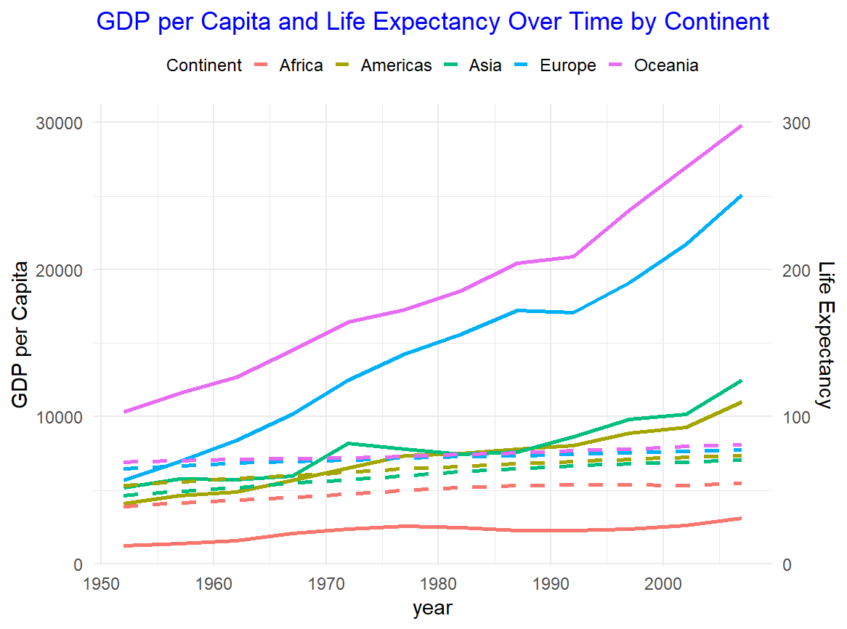

A time series line plot was created to examine the trends of GDP per capita and life expectancy over time by continent. The plot reveals that while GDP per capita has increased significantly over time, life expectancy has also followed an upward trend, particularly in Europe and North America. This suggests that economic growth has contributed to improved living standards and health outcomes, although the relationship is not uniform across all continents.

***4.3 GDP and Life Expectancy Trends by Country (Top 3 by Population)***

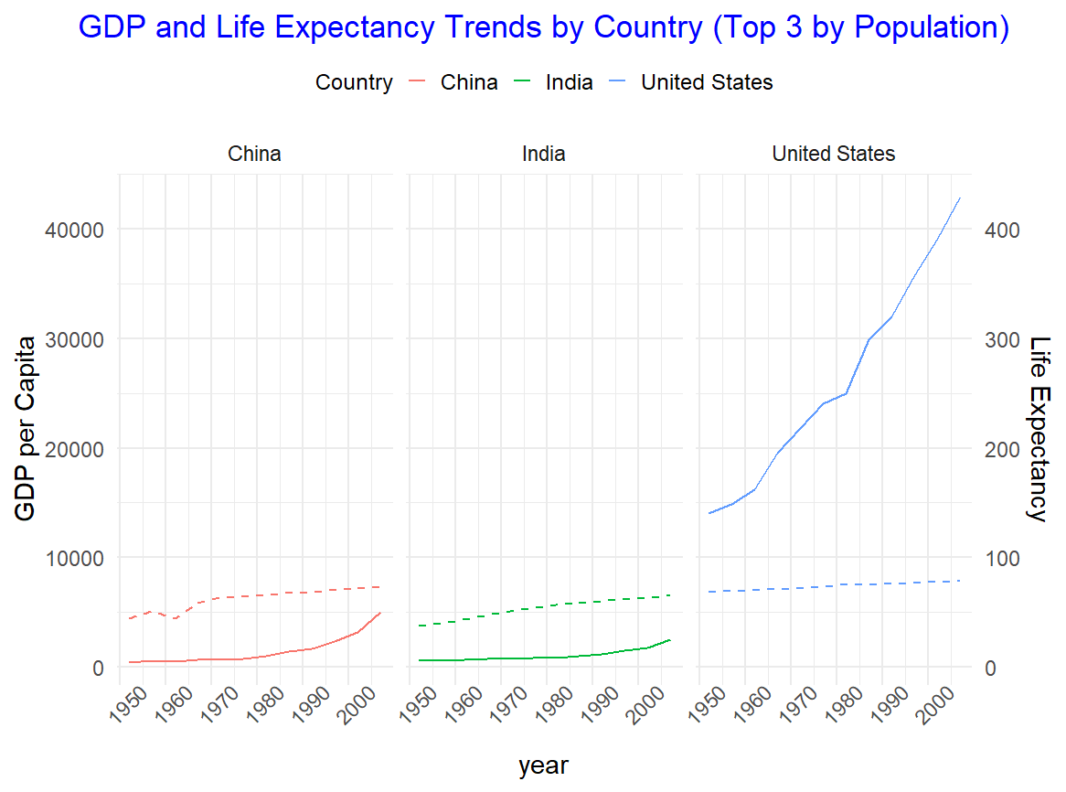

A facet grid plot was used to compare GDP and life expectancy trends for the top 3 most populous countries in the dataset (China, India, and United States). The plots reveal that while the United States has seen consistent economic growth and a steady increase in life expectancy, China and India have experienced rapid improvements in both GDP and life expectancy, particularly in the past few decades.

***4.4 Bubble Plot: GDP vs Life Expectancy with Population Size***

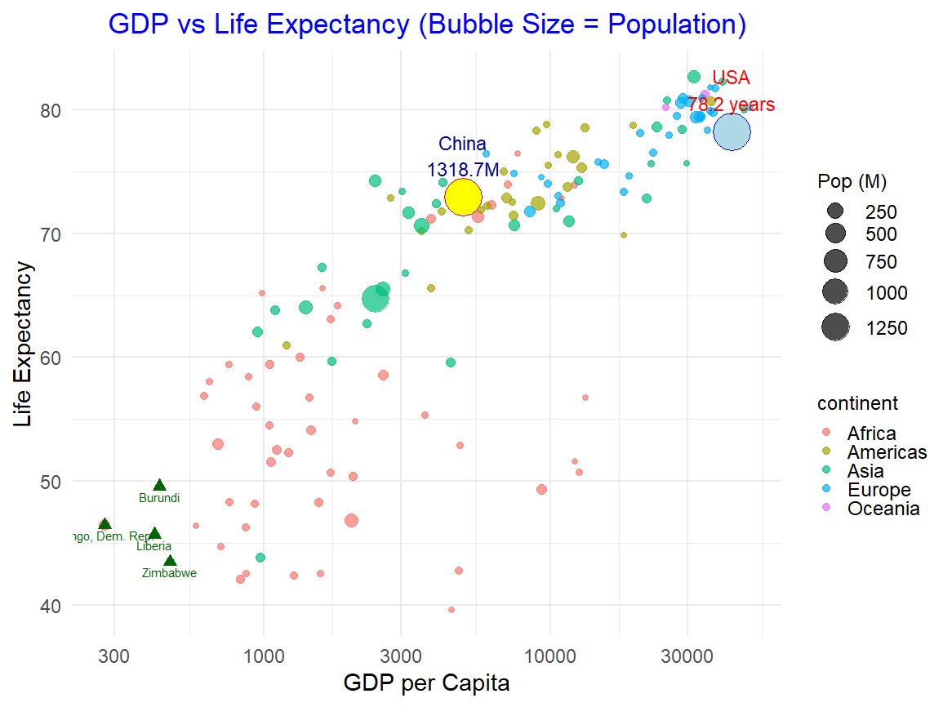

A bubble plot was used to visualize the relationship between GDP per capita and life expectancy, with the size of the bubbles representing population size. This plot highlights how large countries like China and the United States fit into the global landscape of GDP and life expectancy. It also shows that countries with low GDP per capita often have low life expectancy, emphasizing the challenges faced by less-developed nations.

**5. Interactive and 3D Visualizations**

***5.1 3D Cloud Plot: GDP per Capita, Life Expectancy, and Population***

A 3D scatter plot was created to visualize the relationships between GDP per capita, life expectancy, and population size. The interactive plot allows for a more nuanced view of the data, enabling users to rotate the plot and explore the data from different angles. The 3D visualization reveals that countries with larger populations tend to have lower GDP per capita and life expectancy, particularly in Africa and Asia.

***5.2 Wireframe Plot: GDP per Capita vs Life Expectancy and Population***

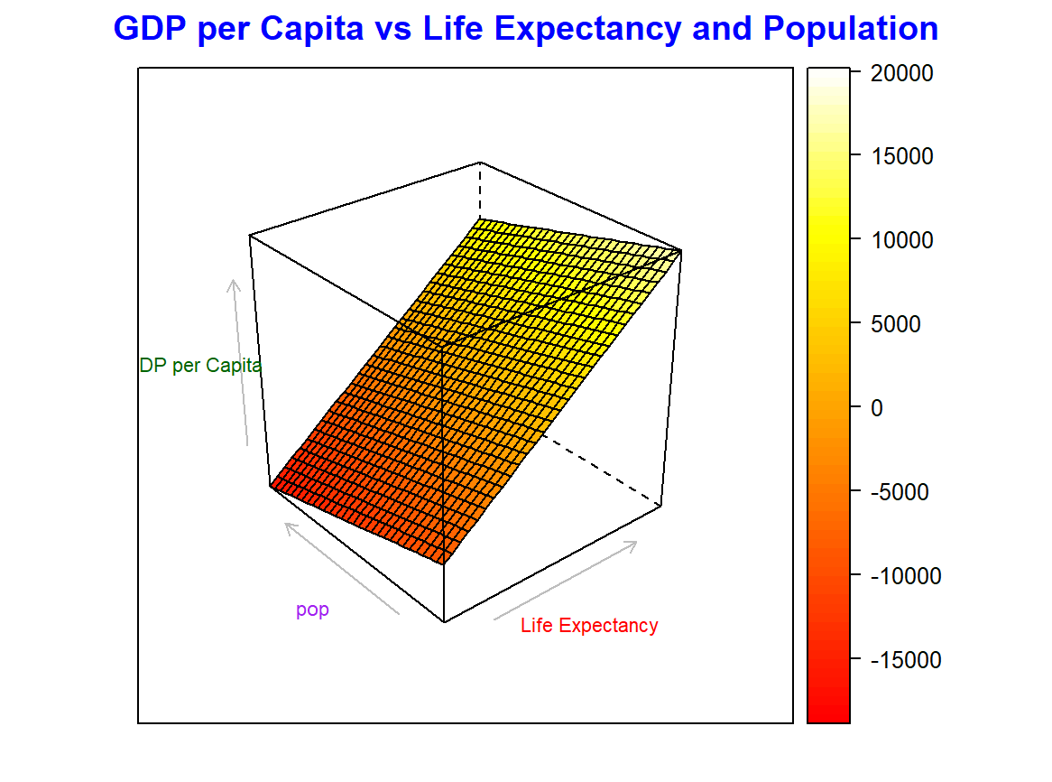

A 3D wireframe plot was used to examine the relationship between GDP per capita, life expectancy, and population. The wireframe illustrates how GDP per capita changes with life expectancy and population size, providing a clearer understanding of the interactions between these three variables.

**Conclusion**

This report has provided a comprehensive analysis of global economic, demographic, and health trends using various visualization techniques. The charts and plots reveal significant disparities between continents and countries in terms of GDP per capita, population growth, and life expectancy. Asia and Africa dominate in population, with Europe and Oceania leading in terms of GDP and life expectancy. These trends reflect global inequalities and highlight the need for targeted policies to address health and economic disparities across different regions.